How Do We Measure Magnetic Resonance Signal?

NMR Spectrometer Basics

Table of Contents

*Expected Learning Outcomes* 2

Background Information 3

Classwide Discussion 4

What are we directly measuring? 4

Guided Inquiry Questions 5

NMR Signal 6

Guided Inquiry Questions 7

More Realistic NMR Signal 8

Guided Inquiry Questions 8

Free Induction Decay 9

Guided Tour of the Different Components of NMR Spectrometer 10

Guided Inquiry Questions 14

Reflection Questions 14

Cited Sources 15

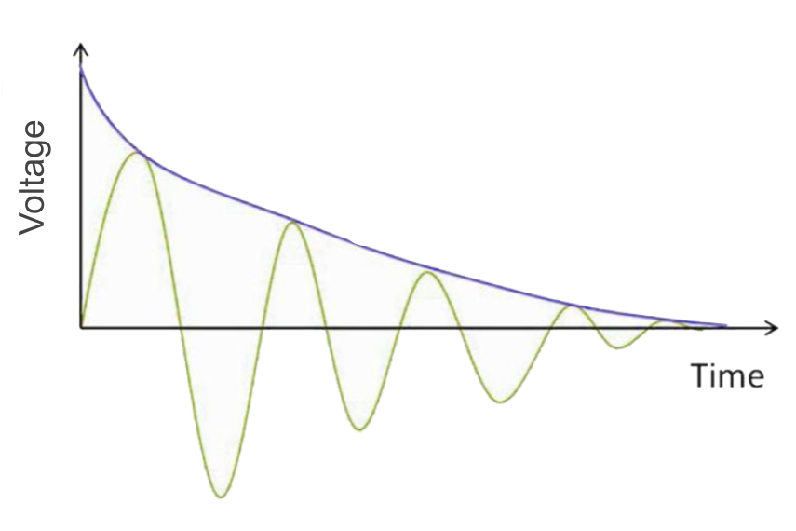

***Example Real-World Application*** Nuclear Magnetic Resonance (NMR) spectroscopy is an analytical chemistry technique that provides multiple ways to characterize chemical samples, including identifying the content and purity of a sample along with its chemical structure. This is an important tool for medical diagnostics, food quality control and research, environmental monitoring, and drug discovery and development.

## *Expected Learning Outcomes*

*At the end of this module, students should be able to…*

1. *Identify what physical quantities are being measured and describe how to acquire magnetic resonance (MR) signal using an NMR spectrometer (*[*Scientific Ability B4*](https://sites.google.com/site/scientificabilities/rubrics)*)*
2. *Extract information and interpret MR signal from oscilloscope correctly (*[*Scientific Ability A1*](https://sites.google.com/site/scientificabilities/rubrics)*)*
3. *Identify which experimental parameters can cause observed changes in MR signal (*[*Scientific Ability G5*](https://sites.google.com/site/scientificabilities/rubrics)*)*

**” I remember, in the winter of our first experiments, just seven years ago, looking on snow with new eyes. There the snow lay around my doorstep — great heaps of protons quietly precessing in the earth’s magnetic field. To see the world for a moment as something rich and strange is the private reward of many a discovery.”** — E. M. Purcell, Nobel lecture, 1952

**Edward Mills Purcell** - a Physics Nobel Prize winner in 1952 (shared with Felix Bloch) for his independent discovery of nuclear magnetic resonance in liquids and solids. Purcell made important contributions in solid-state physics using magnetic resonance techniques and was the first to detect radio emissions from the neutral galactic hydrogen in the Milky Way.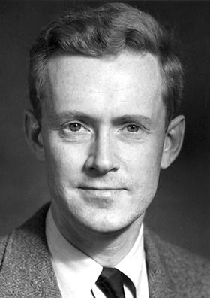

Photographer Unknown, Public Domain (1)

# Background Information

We have seen that by measuring precession frequencies of spins placed in a magnetic field, we can gather useful information about the identities of the spins in the sample (e.g. relative quantities of particular nuclear isotopes), as well as the local magnetic environment those spins are experiencing. In later modules, we will see how the measured frequencies can provide valuable chemical structure information or enable applications like magnetic resonance imaging!

**spectrometers**- instruments that are used for measuring spectral data, which typically consists of recording the responses of a system to different frequencies of electromagnetic radiation

In this module, we are going to learn how scientists collect MR signal using **spectrometers**, the experimental parameters that need to be optimized, and learn how to interpret the data collected from the simplest MR experiment - the free induction decay.

## Classwide Discussion

* If we need to collect frequency data, what would be good states for our spins to be in? *Hint: If they are in a pure spin-up or spin-down state, is there any precession to measure?*
* NMR frequencies are typically in the radio frequency range and ESR are typically in the microwave frequency range, how is that convenient given the other inventions being developed in the early 20th century?

# What are we directly measuring?

***RECALL:*** How did you determine the frequency of precession of the white cue ball in previous modules? Did you acquire this information directly (i.e. you had a device that told you the frequency, or did you have to find it indirectly from observations?)

Frequency information is typically gathered indirectly, usually by watching how different physical parameters change with time. In our experiments measuring the precession frequency of our white cue ball, we had to watch the motion of the axis of rotation (the black handle of the cue ball) circling around the applied magnetic field over some length of time. We then could calculate the frequency from the time it took for the cue ball to complete a single cycle.

Even though we cannot ‘see’ our quantum spins in the same way as the white cue ball, we can indirectly determine the precessional frequency by looking at how associated physical parameters that can be measured more directly change with time. For MR, we get to take advantage of the fact that quantum spins have an intrinsic magnetic moment that behaves like a bar magnet aligned with the spin angular momentum vector (i.e. it is oriented along the axis of rotation). As the quantum spin precesses, so does the spin magnetic moment. The precessing magnetic moment causes a fluctuating magnetic field at the Larmor precession frequency.

**Faraday’s law of induction** states that when a magnetic field is changed, it leads to a voltage that can make electric currents flow around a loop of wire. This concept is one of the most important laws of electricity and explains how the majority of electrical power is currently generated!

Fortunately, physicists have long understood that changing magnetic fields can generate electric potential differences, otherwise known as voltage. (Check out **Faraday’s Law of Induction** in the margin for more information!) You may associate voltage with batteries and electrical power lines, and for good reason! Voltage is a physical quantity that our electric and digital world is built upon measuring, and we can measure even extremely small voltages very well. In the setup below, we show how a rotating bar magnet generates a small fluctuating electrical current in a wire loop due to the induced voltage from the changing magnetic field of the bar magnet.

**Faraday’s Law Demo Video** <https://www.youtube.com/watch?v=JXSWuzAn7yk>

Similar to the video above, if we can get all the quantum spins magnetic moments to align and precess together, the changing magnetic field generated can induce a fluctuating voltage around a loop or coil of wire. Typically the resulting data is voltage measured over time.

**Fluctuating Voltage from Rotating Magnet** <https://www.youtube.com/watch?v=DR6D69YMwqE>

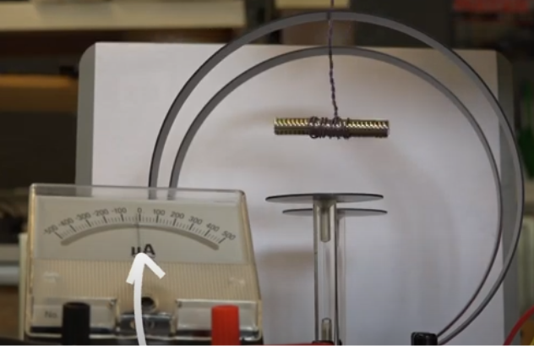

Screenshot from [**Fluctuating Voltage from Rotating Magnet**](https://www.youtube.com/watch?v=DR6D69YMwqE).

## Guided Inquiry Questions

1. Sketch an example of what the voltage versus time data might look like for the experiment performed in the second video when the magnet is being rotated inside the coils of wire. (A rough sketch will do!) If the quantum spins are precessing at the Larmor frequency, what might be a reasonable guess for the frequency of the fluctuating voltage we will be detecting?
2. We need spins to be precessing in order to induce any voltage and measure NMR signal. Draw a picture using the Bloch representation of possible quantum states to put the spins in. Explain your choice.
3. Look closely at the video of the wire loop and the rotating bar magnet in the video above. Everything in the experimental setup was oriented to maximize the signal being measured according to Faraday’s law of induction. Using this video as a guide, draw a possible orientation of the loop of wire we could use to detect the NMR signal next to your Bloch sphere.

# NMR Signal

**net magnetization vector** - a vector quantity that is an average of all the individual spin magnetic moment vectors and gives the overall net magnetization of the sample; typically denoted by

Net magnetization figures courtesy of Allen D. Elster, MRIquestions.com (2)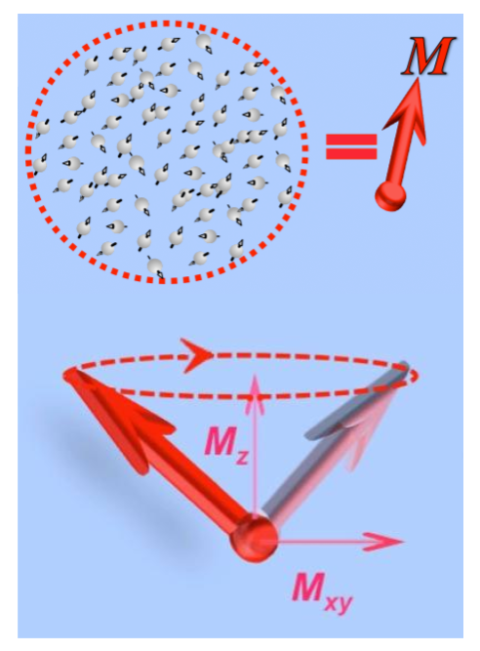

In NMR, scientists are typically looking at the fluctuating voltage signal that is produced from the precessing *averaged* nuclear spin magnetic moment over a lot of individual nuclei known as the **net nuclear magnetization vector** and typically denoted by . The amount of voltage signal collected is directly related to the size of the x- and y-components of the net nuclear magnetization vector ( and , respectively). The projection of onto the xy-plane is denoted by and would be the radius of the circle being traced out in the xy-plane. When is aligned with the magnetic field (the z axis), then and are all zero, and there would be no NMR signal measured. When is precessing, then and would give a sinusoidal signal at the Larmor precession frequency.

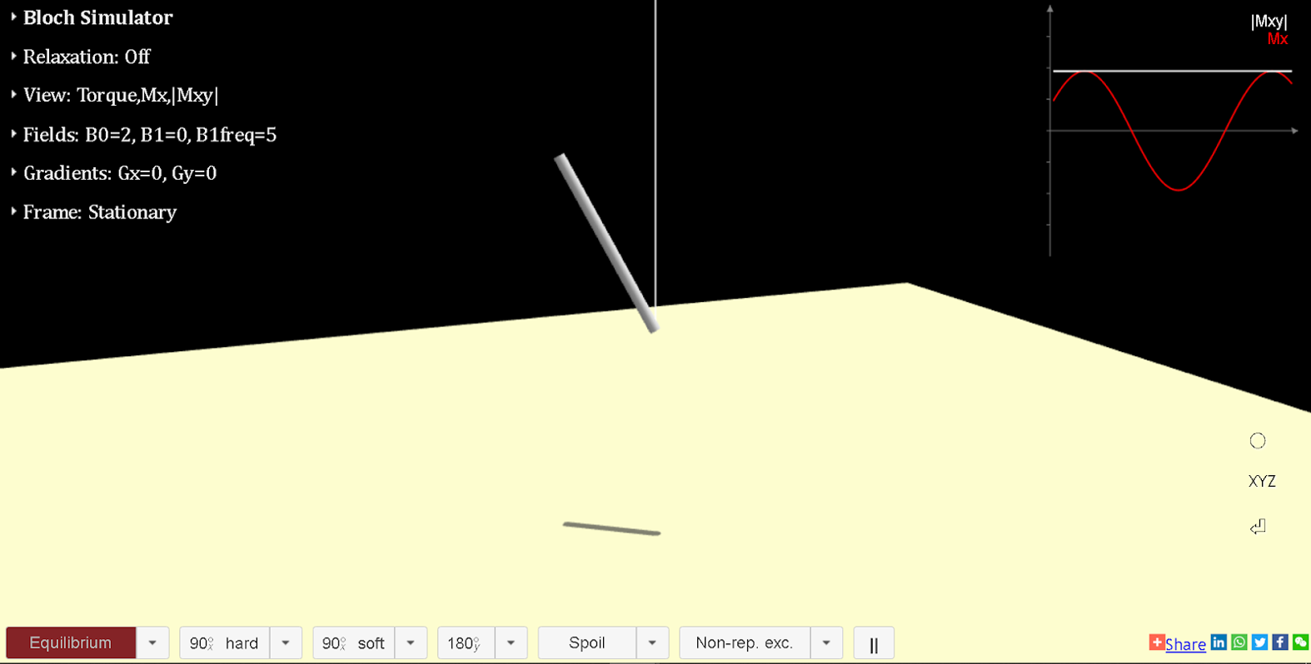

## Guided Inquiry Questions

1. Open the [Bloch simulator](https://www.drcmr.dk/BlochSimulator/) and, without clicking on anything, draw a sketch of the motion of the net nuclear magnetization vector, , and copy down the plot of and in the upper-right corner. Does this match with our description of the NMR signal described in the previous paragraph? How so?
2. In your sketch, draw the orientation of the wire loop that is collecting the red () NMR signal. *Hint: It may be helpful to add some x- and y-axes to your sketch!*
3. Draw a sketch of how the net nuclear magnetization vector should be oriented in order to maximize the red () NMR signal.

# More Realistic NMR Signal

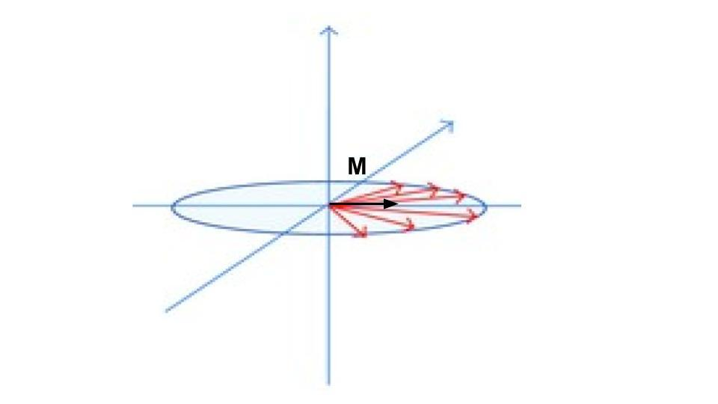

**dephasing** - spins (best viewed in the rotating frame, as shown above) get out of phase with each other due to small differences in precession frequencies; the more dephasing, the smaller the magnitude of the net nuclear magnetization vector, $\vec{M}$

In reality, each nuclear spin may see its own unique local magnetic field due to **inhomogeneities** (differences throughout space) in the external magnetic field as well as proximity to other nuclear spins. This unique magnetic environment for each spin causes each spin to precess at a *slightly* different frequency. Instead of all the spins precessing exactly in phase - so that the net nuclear magnetization vector, is following precisely the same motion as all the individual spin magnetic moments - the spins will start **dephasing** causing the magnitude of to get smaller and smaller, as the spins get farther and farther ‘out of step’ with each other. Let’s look at the impact on the resulting NMR signal using the Bloch simulator.

## Guided Inquiry Questions

1. Open the Bloch simulator, select “Inhomogeneity” instead of “Equilibrium” in the drop-down menu, and then click on “ hard”. Describe what you are seeing.
2. Copy down the plot of and and explain why it looks that way. Try to make use of *inhomogeneities* and *dephasing* in your explanation. *Hint: Think of what the net nuclear magnetization vector would be doing in this experiment.*

## Free Induction Decay

The plot that you just sketched is the expected MR signal from a **free induction decay** experiment, the simplest and most commonly used experiment in NMR.

**Free Induction Decay Signal (FID) and**  This NMR signal that results after hitting an initialized sample with a 90-degree pulse, is called **free induction decay** and is typically a decaying exponential with characteristic decay time, . The cause for this signal decay is predominantly due to inhomogeneities in the applied magnetic field causing dephasing of spins in the transverse plane.

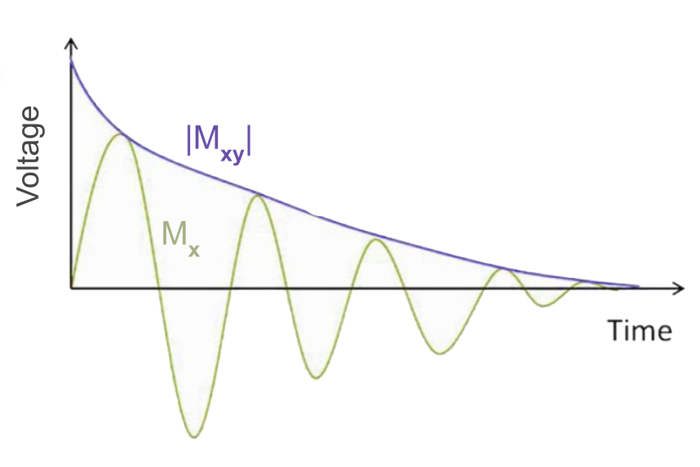

This depiction maps directly to the actual free induction decay signal you would see on an oscilloscope that is looking at the outputted signal from the TeachSpin benchtop NMR system described in the following section.

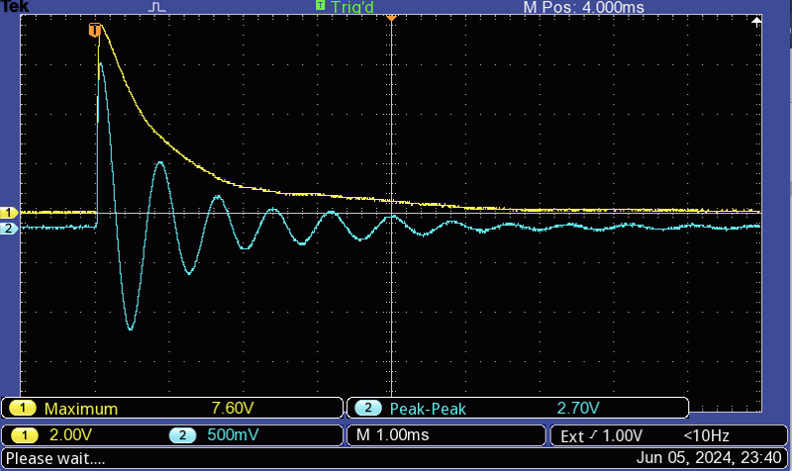

*Some questions to consider:* Which oscilloscope trace (blue or yellow) corresponds to ||$? ?

# Guided Tour of the Different Components of NMR Spectrometer

In order to acquire the NMR signal, there are several key components of an NMR spectrometer necessary: (1) a magnet, (2) rf coil for transmitting pulses and receiving rf signal at the desired Larmor frequency, (3) electronics to produce the pulses, and (4) electronics to amplify, filter, and output the signal. Many of these components are hidden away from the user, so that experiments can be run automatically without much user input. However, there are some instruments (like the TeachSpin instrument in the figure below) that explicitly label the different components that we will use so that you will be a far more informed user of NMR spectrometers.

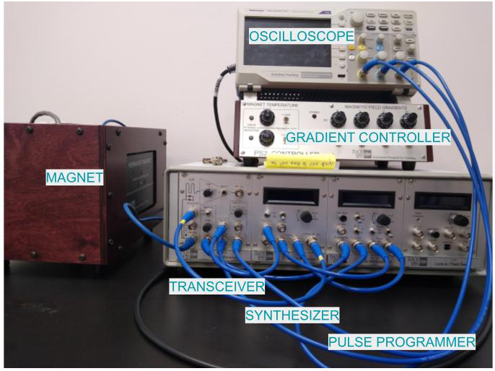

Here’s some more information about the different components of the TeachSpin system shown above.

* **Magnet** - this houses a permanent magnet and the sample is inserted at the top and lowered into a region between the two poles of the permanent magnet.
* **Gradient Controller** - this gives control knobs for magnetic field gradients to have some control of the homogeneity of the magnetic field amplitude over the sample volume. These are usually set at good values to create a nice homogeneous magnetic field and should be left alone unless otherwise instructed The gradient controller is just connected to the magnet system and the main point is keeping the magnetic field as stable and homogeneous as possible.
* **Oscilloscope** - a very important and useful electronic instrument that graphically displays time-varying electrical voltages as 2D plots with voltage along the y-axis and time along the x-axis. This allows us to visualize the NMR signal being acquired, which is usually either associated with , , and/or . The NMR signal outputted by the transceiver ultimately arrives here for visualizing the signal.
* **Transceiver** - this is a combination transmitter and receiver and is the piece of electronics that sends out the pulses and receives the NMR signal and outputs this signal to be visualized on the oscilloscope and/or recorded electronically. Since the frequency of the signal is in the RF (MHz) region, the TeachSpin system subtracts out the transmitted RF frequency in the output so that you typically just see oscillations due to small deviations from the Larmor frequency in the audio (kHz) region. (Yes, you could potentially ‘listen’ to the audio signal output from the TeachSpin!)
* **Synthesizer** - this generates sinusoidally-varying voltages at precise RF frequencies to be used for the transmitted pulses. The synthesizer, combined with information from the pulse programmer, outputs the pulse sequence to the transceiver that gets transmitted to the sample inside the magnet.
* **Pulse Programmer** - this generates the pulse sequences by providing pulses with correct lengths and timing that can be mixed with the synthesized sinusoidal signal of the synthesizer.

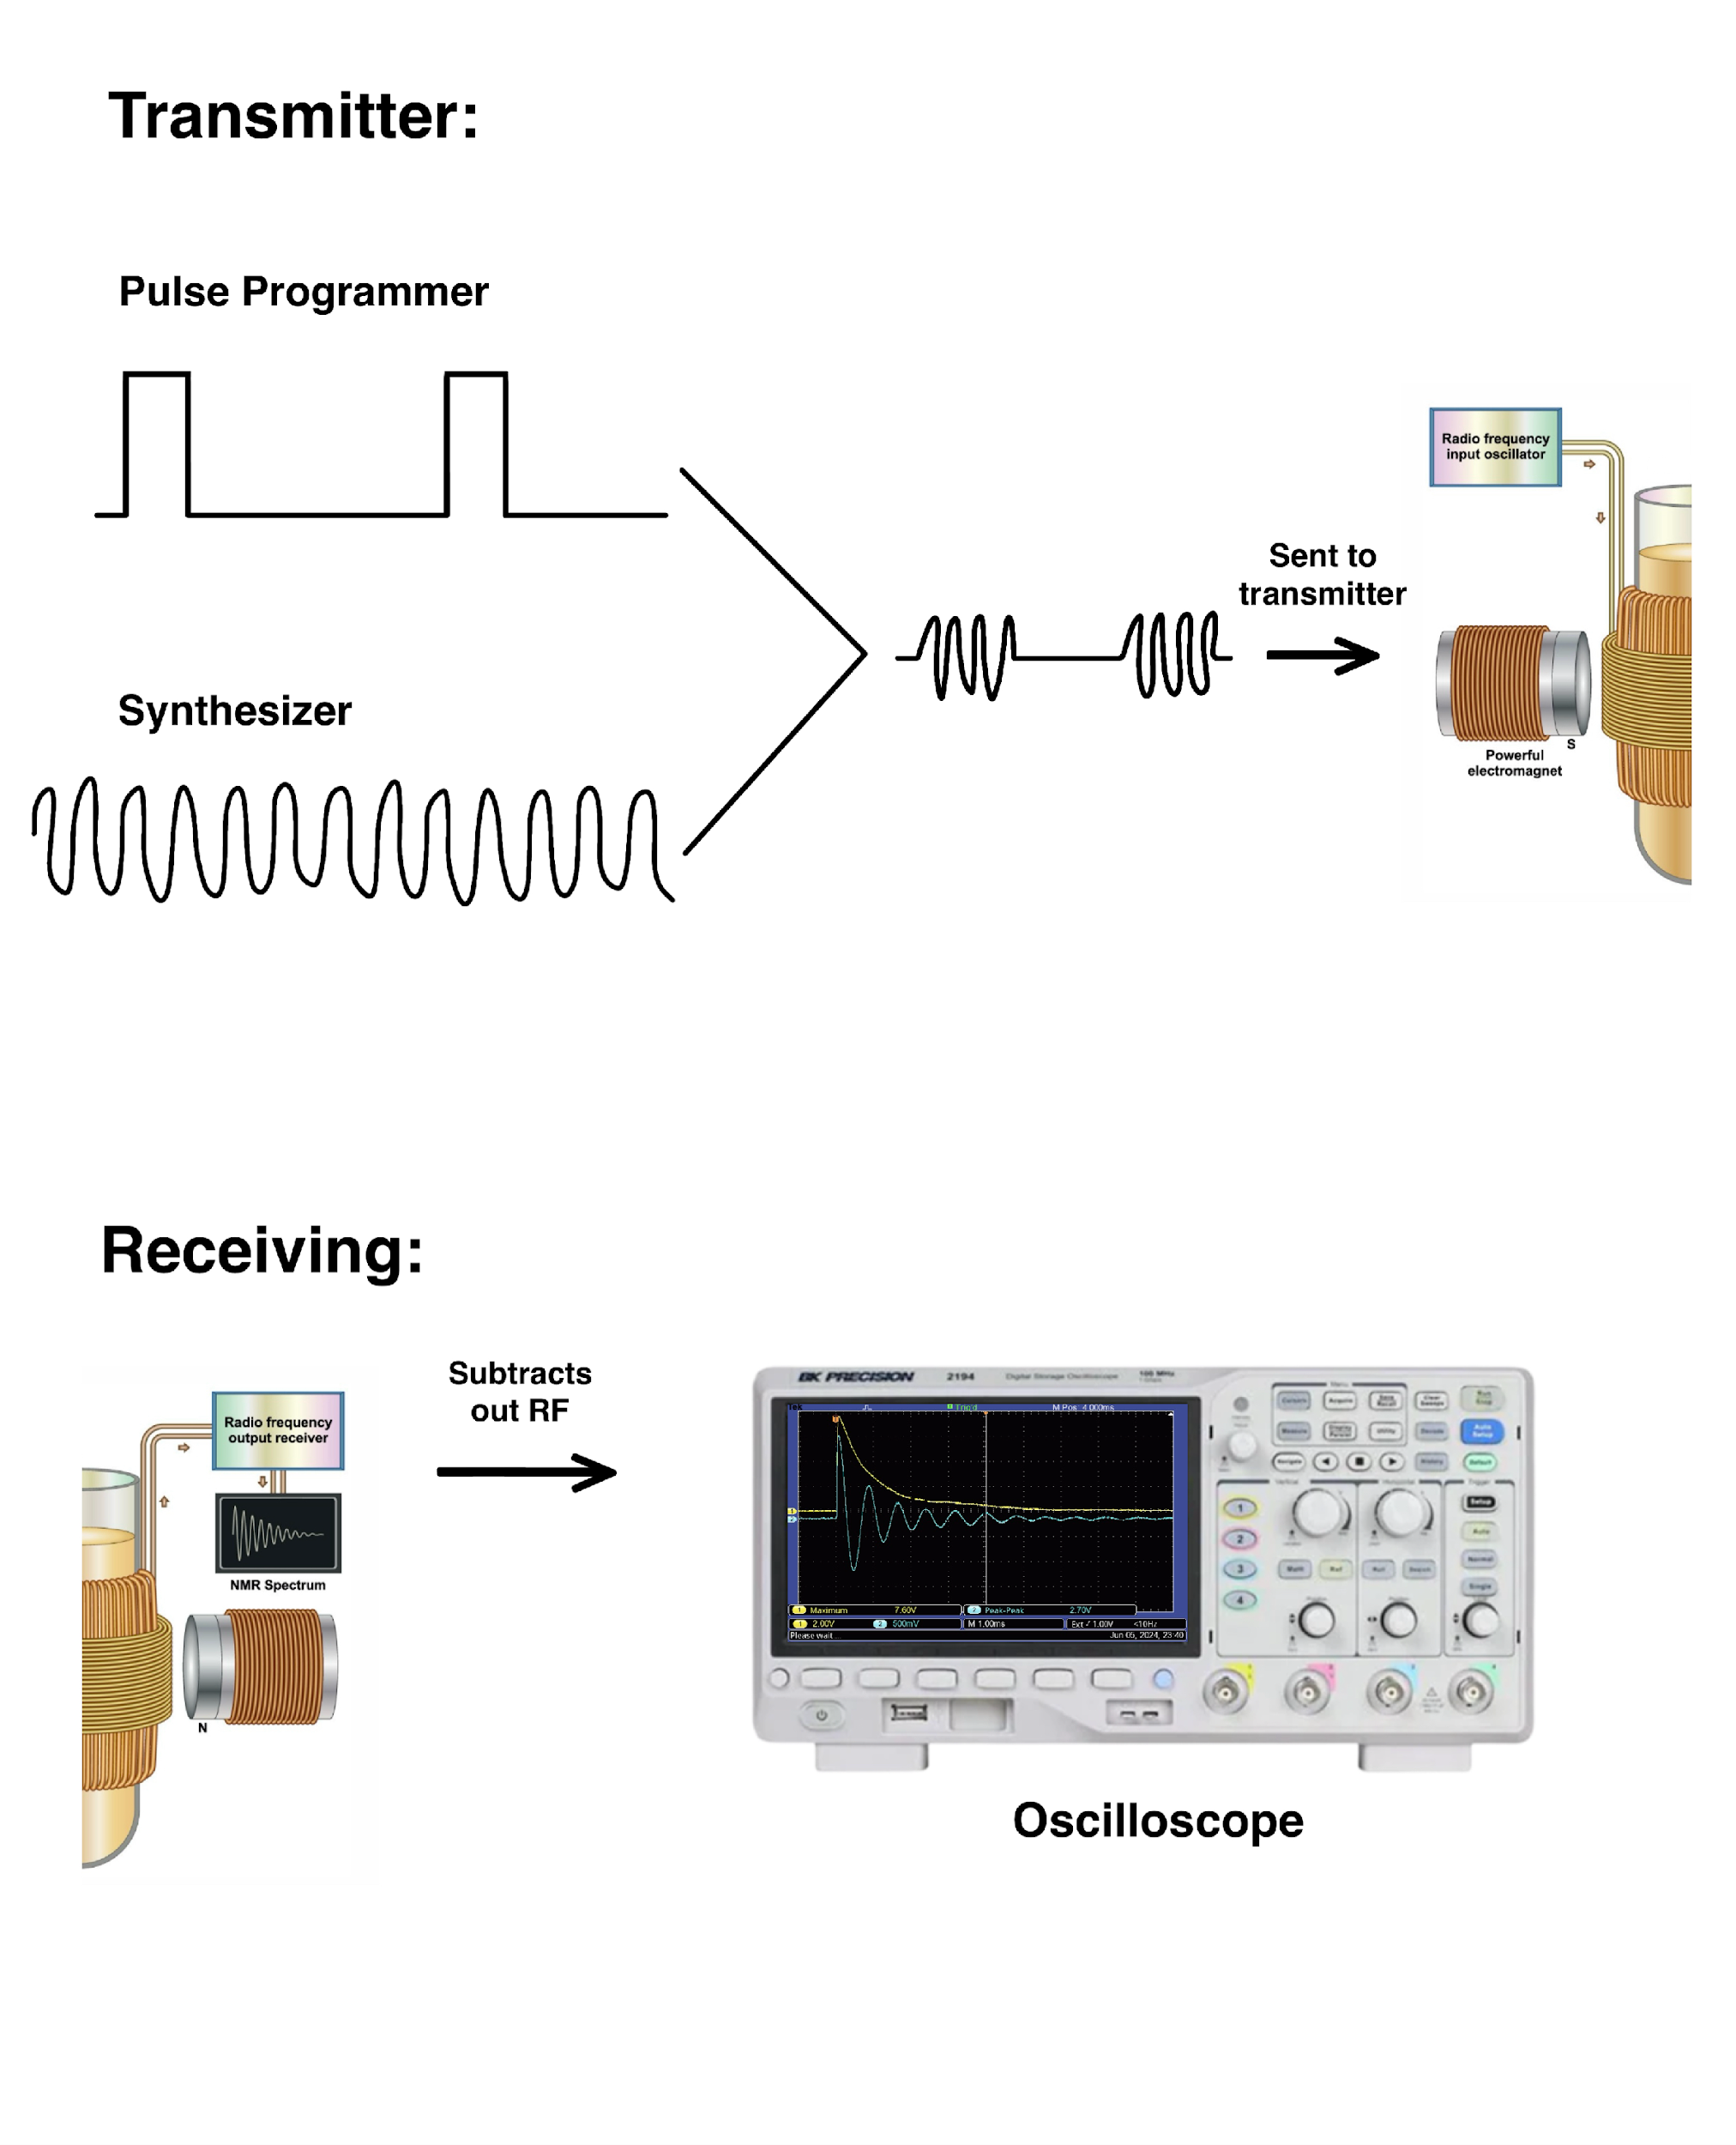

The primary settings of the spectrometer that will effect the FID signal:

* **Frequency** - this changes the frequency of the pulses, as well as the frequency being subtracted by the received signal so that differences from the pulse frequency are easier to see. (The more oscillations you see in the output signal, the farther off the pulse frequency is from the Larmor frequency). The largest signal is obtained when the frequency equals the Larmor frequency of the spins. This is often *not* a knob in traditional NMR spectrometers and is set by the machine depending on the nucleus selected and the known magnetic field of the device.
* **Pulse Length** - this changes the length of the pulses, and thus how much the spins are being rotated away from the magnetic field. The largest signal appears when the spins are rotated from equilibrium 90-degrees into the xy-plane, called a 90-degree pulse. The smallest signal appears when the spins are rotated from equilibrium a full 180-degrees (a spin-flip).
* **Period or repetition time (TR)** - this changes the length of time before another pulse sequence is sent. The largest signal is when the repetition time (TR) is longer - though this also increases the total time the experiment takes, so experimenters often have to balance the two concerns of signal versus experiment time.

## Guided Inquiry Questions

The videos below show NMR signal from the TeachSpin benchtop NMR spectrometer as shown on an oscilloscope. The yellow trace corresponds to and the blue trace corresponds to after subtracting out the input frequency of ~21 MHz.

1. Check out this YouTube video <https://www.youtube.com/watch?v=SayyvFx6L1I>. Which of the three primary spectrometer settings is being changed during the course of this video? Explain how you arrive at your conclusion.
2. Check out this YouTube video <https://www.youtube.com/watch?v=5VK8XQ2z_qM>. Which of the three primary spectrometer settings is being changed during the course of this video? Explain how you arrive at your conclusion.
3. Check out this YouTube video <https://www.youtube.com/watch?v=L7wS_iK9yqE>. Which of the three primary spectrometer settings is being changed during the course of this video? Explain how you arrive at your conclusion.

# Reflection Questions

1. Explain how the free induction decay experiment is designed to maximize NMR signal. *Hint: Consider why a 90-degree pulse is used and why this generates the most signal given what you have learned about Faraday’s law and ways to orient the receiver coil relative to the rotating bar magnet in order to maximize the voltage induced.*
2. All three primary spectrometer settings can affect the size of the NMR signal (the overall maximum voltage of the signal as observed on the oscilloscope). If you observe the amplitude changing in the signal, how can you differentiate whether it is the frequency being changed as opposed to either the pulse length or the repetition time?
3. You are unsure if the signal you are seeing is coming from the sample or from leakage coming from the transmitted pulse. (This can occur since we acquire the signal right after the pulse and are using the same coil for both transmitting and receiving!) What are some things you can try to do to verify if the signal is indeed coming from the sample?

## Cited Sources

1. <http://nobelprize.org/nobel_prizes/physics/laureates/1952/purcell-bio.html> “Purcell Nobel Prize Bio”
2. <https://www.researchgate.net/publication/221889922_Magnetic_Nanoparticles_in_Magnetic_Resonance_Imaging_and_Diagnostics> “Figure 3 - Illustration of Nuclear Net Magnetization created by Christine Rumenapp”